Discussion Question
1-Consider the eight steps of making public policy and failed public policy issues like prohibition. (See Chapter 12 power point slide 33) What can be done to ensure that effective public policy is created? How should a government evaluate and consider intended and unintended consequences?

https://www.khanacademy.org/humanities/us-history/rise-to-world-power/1920s-america/a/prohibition

2-What was the main reason why the American Revolution was fought? Why was the Presidency created? How has the power of the Presidency been expanded over the past century? Should action be taken to curb the power of the Presidency? What Presidents have been impeached and what does impeachment mean?
Answer a few or all of the questions above in order to meet the required word count

3-IDEAS.TED.COM
Top of Form
Search for:
Bottom of Form

WE HUMANS

How to talk about politics constructively
Oct 19, 2016 / Celeste Head lee

iStock

We must begin to talk and, more importantly, listen to those who disagree with us, says Celeste Head lee. She offers smart ways to discuss politics without getting in a fight.
I overheard someone in the line at Starbucks in Atlanta, talking about a co-worker. “I asked HR to move my desk today,” she said. “I just can’t talk to Rachel anymore, even about work. She’s got Trump stickers all over her car. What could I possibly say to her?”
I’ve heard some version of this complaint on a regular basis for at least the past year. At one point, it was a Bernie supporter talking about someone who is voting for Hillary. Another friend on Facebook just posted an angry message to anyone who’s voting third party: “Just unfriend me. You are not just making a mistake. You are a bad person.” (I’m paraphrasing for privacy’s sake.)
I’m not here to scold you or shame you or make you feel bad for avoiding political discussions. I totally understand why someone would do that, and I’ve done it myself. We live in an age in which it’s very difficult to avoid conversations about politics because nearly everything has become political. And a difference in political matters can cause arguments that end friendships, marriages, even business relationships.
While I understand why we all avoid talking about politics, I still think it’s time to get over our discomfort and wade in. Look around your neighborhood, your city, your state, our nation and our world. I’m not so naïve as to believe that conversations can solve the world’s problems, but I can say with confidence that not having those conversations make those problems significantly worse. So, we must begin to talk and, more important, listen to those who disagree with us on refugees, privacy rights, taxes and even religion. We must have the conversation so we can eventually reach the compromise.
To that end, here are some strategies on how to talk about politics without getting into a fight.

1. Don’t try to educate anyone.
Don’t start a conversation intending to prove someone is wrong or to change their mind. Neurological research shows that it’s really hard to change our own minds, let alone someone else’s. If that’s your goal, you will be disappointed, and you’ll probably annoy the person you’re speaking to.

2. Don’t pre-judge.
Listen to people with an open mind. If someone likes a candidate that you hate, that doesn’t mean you should discount everything they say or that you won’t find common ground. Amaryllis Fox, a former Clandestine Service Officer with the CIA, talked recently about how she was able to talk with extremists whose actions she deplored. She said, “Everybody believes they are the good guy. The only real way to disarm your enemy is to listen to them. If you hear them out, if you’re brave enough to really listen to their story, you can see that more often than not, you might have made some of the same choices if you’d lived their life instead of yours.” I don’t believe she’s saying you have to approve of their decisions or philosophy. I think she’s talking about empathy, having the ability to understand why someone believes what they do. If you dehumanize another person, it’s very difficult to converse with them. The purpose of listening is not to endorse, but to understand.

3. Show respect.
Respect is more important than tolerance. To respect another person is to refrain from calling them names, discounting their ideas or using frequent interruptions to talk over them or perplex them. It also means taking turns, so that you allow them to respond to your questions and share an equal time to express their point of view. Showing respect means that you accept the other person has made choices for what they think are good reasons and that you accord them the right to express their opinions. The vast majority of people you know believe they are doing the best they can. They truly believe that their candidate or their policies will make the world a better place. Practice seeing people with whom you disagree as people who are trying to achieve a positive result.

4. Stick it out.
When a conversation becomes awkward or difficult, work through it. Don’t crack a joke or change the subject, just work through the awkwardness. Keep going through the fog because the light is bright on the other side. It can be tempting, as soon as someone expresses a strong opinion on abortion or immigrants or civil rights, to test the waters with a comment or two. If you find the water too hot, you yank that toe out and run from the room. But the most important conversations are those that people are the most passionate about, those that people are the most emotional about. They are messy and frustrating and even uncomfortable, but they’re also often worth it. And they are necessary if we are to find common ground and begin to solve some of the serious problems facing our global society.
I am, of course, not recommending that you remain engaged with someone who is verbally abusive or purposefully offensive. If someone is insulting you, that’s a sure sign that they aren’t interested in a productive conversation and you should walk away.
But if there’s a chance that you might hear a new perspective or learn about another’s experience, it’s worth the frustration. If there’s a chance you might enlighten someone else with your view or help them see the opposing side as human and worthy of respect, it’s worth the time and the effort.
You will probably not reach agreement in a discussion about politics. You will most likely not convince them to change their opinions or worldview. But you might get them to think more carefully, and that’s valuable.
There’s joy in the exchange of ideas, even those that are in opposition. There is enlightenment in simply understanding another’s perspective. So, let’s prepare ourselves to hear things that we don’t like. Let’s take pleasure in hearing from someone whose ideas are at odds with our own, knowing that new perspectives make us stronger and wiser. Let’s start the conversation.
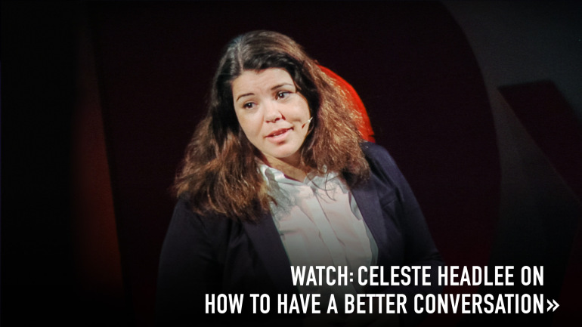

ABOUT THE AUTHOR
Celeste Headlee is the host of the daily news show, "On Second Thought," on Georgia Public Broadcasting.
- argument
- Celeste Head lee
- constructive
- conversation
- discussion
- politics
Advertisement

FRESH IDEAS IN YOUR INBOX
Top of Form


Bottom of Form

TED TALK OF THE DAY


CATHY MULZER

The incredible chemistry powering your smartphone


WE HUMANS

How a great conversation is like a game of catch


WE HUMANS

What a difference a word can make: How a single word can change your conversation


WE HUMANS

How to talk to strangers

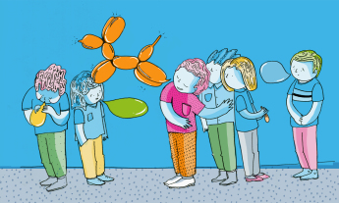
WE HUMANS

How to turn small talk into smart conversation

- TED Talks Usage Policy
- Privacy Policy
- Advertising / Partnership
- TED.com Terms of Use
- Contact
- Jobs
- Press
- Help
© TED Conferences, LLC Powered by WordPress.com VIP

